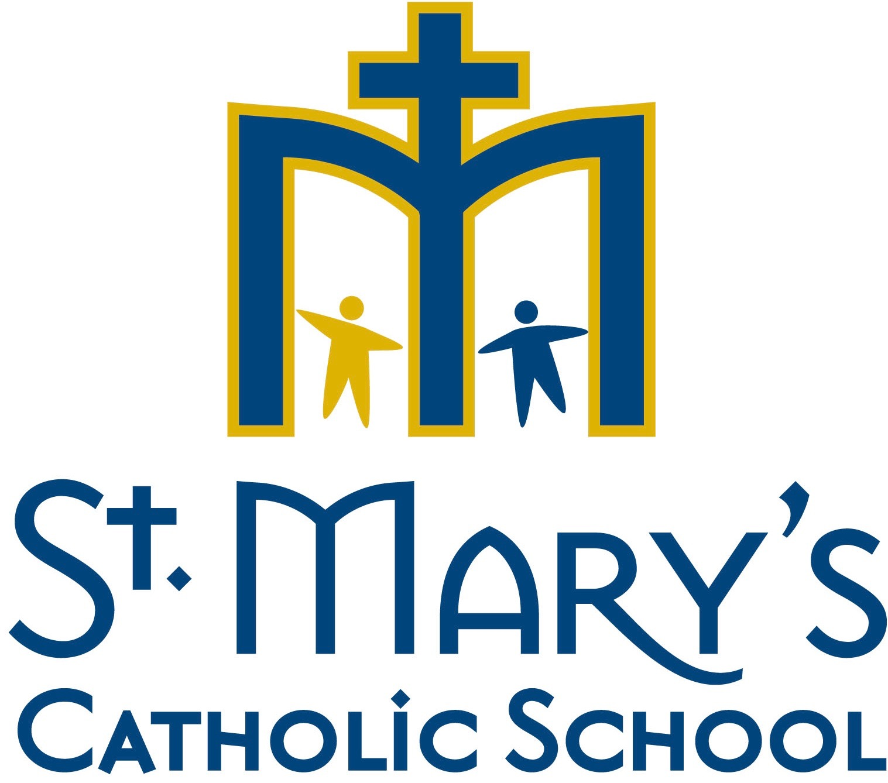

Dear Parent/Guardian,

In order for St. Mary Catholic School to continue to be able to provide your student with the most effective web-based tools and applications for learning, we need to abide by federal regulations that require a parental signature as outlined below.

St. Mary Catholic School would like to utilize a computer software application and web-based service, Google Apps for Education, operated not by St. Mary Catholic School, but by a third party.

In order for our students to use these programs and services, certain personal identifying information, generally the student’s name and email address must be provided to the web site operator. Under federal law, these websites must provide parental notification and obtain parental consent before collecting personal information from children under the age of 13.

The law permits schools such as St. Mary Catholic School to consent to the collection of personal information on behalf of all its students, thereby eliminating the need for individual parental consent given directly to the website operator.

This form will constitute consent for St. Mary Catholic School to provide personal identifying information for your child consisting of first name, last name, email address and user name to the following web-operator: Google Apps for Education.

Please be advised it is necessary that this form be signed and returned by Friday, September 14, 2018 to the classroom teacher.

Student First Name Last Name (please print) Grade Level (2018-2019)

Parent/Guardian Name (please print) Date

Parent/Guardian Signature

